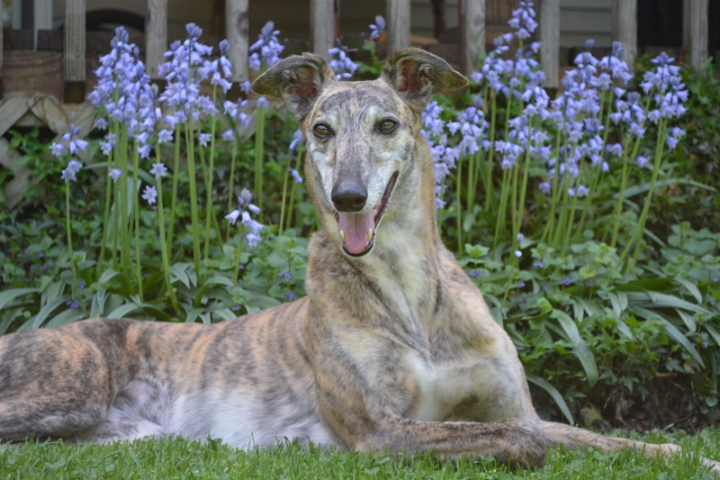

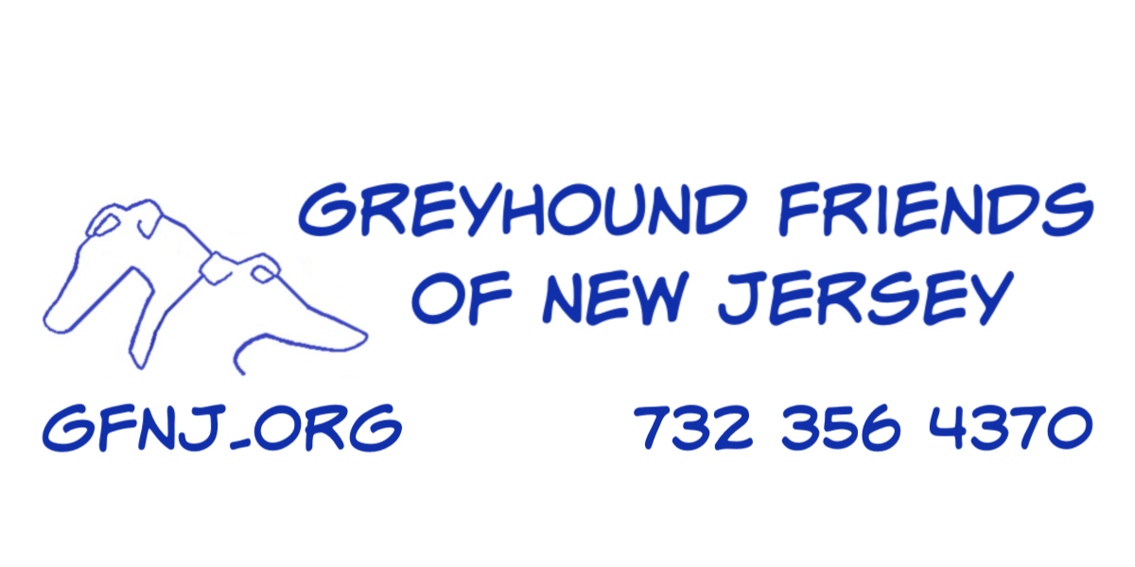

You Want to Adopt a Greyhound

You’ve come to the right people. Over the past quarter century, GFNJ has found the best homes for thousands of greyhounds. We proudly offer our adopters life-long support through close, easy-access communication. Our highly experienced volunteers are always
available to answer a question or help with a problem. We want you
and your new greyhound to be happy.

Unlike some organizations, GFNJ turns no greyhound away. We welcome retired racers of all ages and colors. Every year, our experience, caring and devotion results in the successful placement of hundreds of greyhounds.  The adoption fee helps pay for spay/neuter surgery, teeth cleaning, inoculation, worming and heartworm testing before adoption, but it is not enough. As a non-profit organization, we rely on donations to cover the costs of rehoming greyhounds, so we invite adopters to participate in our fund-raising events. | 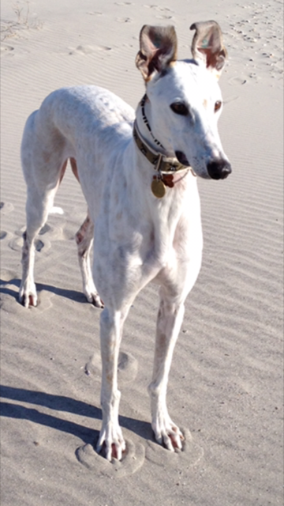

Take your time and do some research to decide if a greyhound is right for you and your lifestyle. Pick up a copy of “Retired Racing Greyhound for Dummies” by Lee Livingood, which will answer questions you may not think to ask.

GFNJ
PO Box 4416
Cherry Hill, NJ 08034

Keep Your Dog Safe

Leashes are a must for greyhounds in any unfenced area! Since they can see clearly for a ½ mile and can reach 45 mph in three strides, they could see something and be out of your reach before you realize it. A tight grip on a leash wrapped around your wrist will keep your dog safe and close by. If he gets loose, his strong running instinct can take him out of sight in no time, risking his being hit by a car or lost.

Since they can reach high speed in a flash, a Flexi-leash should never be used on greyhounds. Wind-up leashes are dangerous and can result in severe injuries.

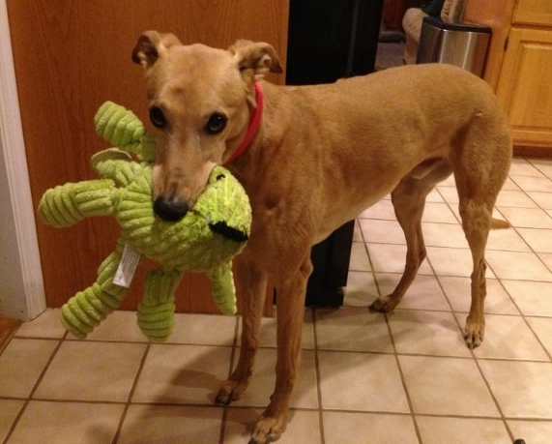

The Application

Once you decide you want to adopt a retired racing greyhound, you must submit an application, which can be easily done online. Go to our web site at gfnj.org to fill out an application. If you do not have access to a computer, please call us at 732-356-4370.

When we receive your application, a GFNJ volunteer will contact you to answer any questions you have. This information will help us work with you to find the right greyhound.

Understanding Greyhounds

Greyhounds are eager to please and learn quickly about life outside the track, mastering stairs and learning about windows and sounds that may seem frightening at first. An understanding environment is best to help the dog adjust quickly to a new home. Some people assume greys are hyper, because of their athletic prowess, when in fact, they spend most of their day lazing on pillows, enjoying a good walk or romp in a fenced yard every day. We call them 45-mile-per-hour couch potatoes.

Life at the Track

It’s helpful to know how greyhounds live before they are retired. The dogs begin their racing career at 18 months and may be raced until they are five years old. If they do not do well on the track, they are made available to adoption groups, usually between 2 to 4 years old.

At the track, greyhounds spend of their time in crates and live by a schedule. They wake, eat and are turned out (usually four times) at the same times daily. Packs of dogs run in large fenced pens, all wearing muzzles. Although they are not housebroken, they rarely dirty their crate, so they usually housebreak easily and quickly using crate training at home.

Arrival at GFNJ

GFNJ greyhounds are housed in a boarding kennel or foster home when they first arrive from the track. Each dog’s temperament is assessed to determine what kind of family would be best. They are also cat-tested to establish whether they can live with a cat or small dog. They are bathed, wormed, treated for ticks and given heartworm preventative. Adoption events at the kennel and some of our fund-raising events are good opportunities to meet dogs – just watch our web site for details.

Temporary Foster Homes

Some of our greyhounds go to foster homes with experienced GFNJ volunteers.

GFNJ
222 Long Neck Circle
Millsboro, DE 19966

Things You Need For Your New Greyhound:

Crate: We recommend using a crate for housebreaking.
Remember, your dog is used to being in a crate, which offers them a feeling of security when they want to be alone, too. Make sure it is large enough for your grey to stand and turn around.

Martingale Collar & leash: You will receive this special greyhound collar and a six-foot leash when you pick up your dog. Their slim heads allow greys to back out of a traditional collar, making
martingales absolutely necessary. Flexi-leashes must not be used under any circumstances!

Food: Kept at a low weight for racing, greyhounds are thin when they arrive from the track. Although a few ribs should always be slightly visible, good food will help them put on weight and make their coats shiny and soft. We recommend a 1 ½ to 2 cups of high-quality, high-protein dry food (moistened with water) twice a day.

Pillows or dog bed: A large, soft pillow will make your couch
potato very happy and is a necessary part of their needs.

Bowls: Bowls should be large enough to hold two cups of dry food and another for fresh water.

Coats: If you need a coat, your grey needs one, too. Since they have thin skin, little body fat, and only one layer of fur, greys need a coat whenever the weather is chilly. GFNJ offers a variety of styles and colors.

Muzzle: You will be given a muzzle when you pick up your dog to make the introduction safer.

If I’m Loose, I’m Lost: When you pick up your new greyhound, please
bring a tag with those words and your home/cell phone numbers on it.

You can discuss all these items and anything else with GFNJ
adoption volunteers when you come to adopt your dog. Do not
forget, we have a lot of experience and can help through the early days.

Join GFNJ on Facebook, Instagram and Twitter!

