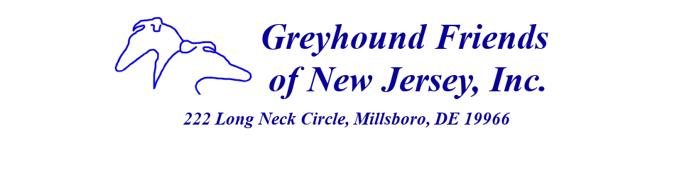
Expense Reimbursement

Please staple your receipts to this form.

Name
Address
City, State, Zip
Phone Number
Date
List each receipt below with the following information for each receipt:
Date of Receipt Reason for Purchase/Event Amount

Your Signature Patty Comerford Approved By ____________________
Date Check # ____________________
Amount ____________________
Date ____________________

Mail to: Linda Lyman, 222 Long Neck Circle, Millsboro, DE 19966
Keep a copy of all of your receipts

