Diamonds Are A Girl's Best Friend
Raffle to benefit Greyhound Friends of NJ Special Girls
Help Support Lizzy, an adorable Alabama girl
Diagnosed with Megaesophagus
and three broods-- Tweetur, Khedia and Uwasa
waiting for forever homes and comfy beds
Take a chance! You could own this gorgeous 1.5 carat pave' diamond ring, set in a contemporary white-gold setting.
Size 7 but can be sized. Valued at $2500-$3000.
Generously donated by adopter, Cathy Hutton.
Raffle drawing will be held at the Fall Picnic, September 18--you do not need to be present to win.
Ticket Prices
$10: One Ticket
$50: Six Tickets
$100: Fifteen Tickets

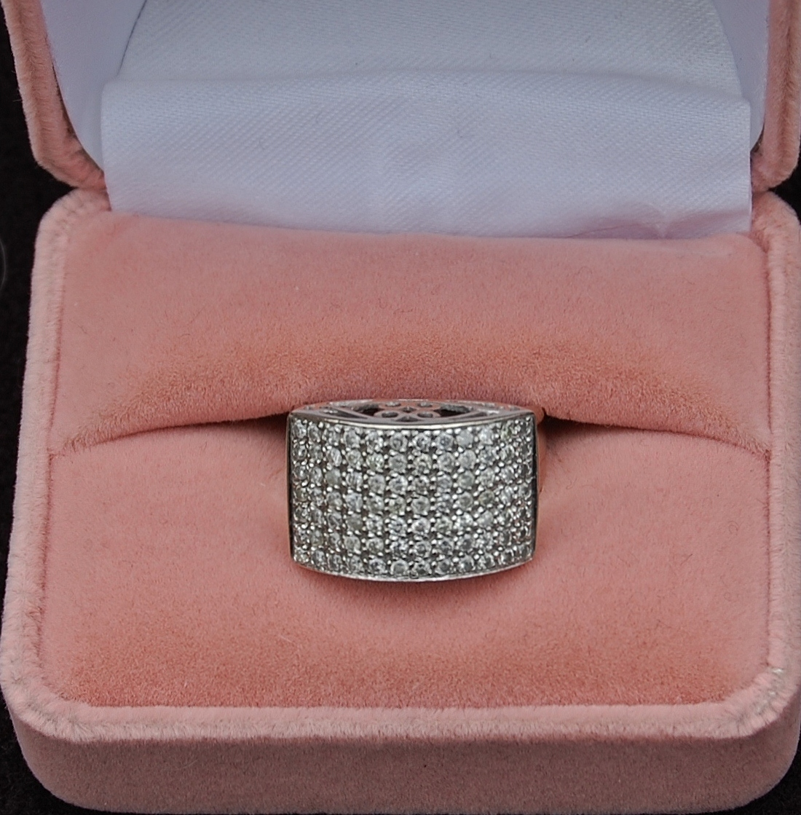

Send to:
GFNJ
PO Box 4416
Cherry Hill, NJ
08034

Thank You

Name__________________________________________
Address_______________________________________________________________________________________Phone ________________________________________
E-Mail _________________________________________
Registration Number 99-5-37193
Name_________________________________________
Address______________________________________________________________________________________
Phone ________________________________________
E-Mail_________________________________________
Registration Number 99-5-37193

Name__________________________________________
Address_______________________________________________________________________________________Phone ________________________________________
E-Mail _________________________________________
Registration Number 99-5-37193
Name__________________________________________
Address_______________________________________________________________________________________Phone ________________________________________
E-Mail _________________________________________
Registration Number 99-5-37193

Name__________________________________________
Address_______________________________________________________________________________________Phone ________________________________________
E-Mail _________________________________________
Registration Number 99-5-37193
Name__________________________________________
Address_______________________________________________________________________________________Phone ________________________________________
E-Mail _________________________________________
Registration Number 99-5-37193

